Experiment 11 — FAISS Document-to-Vector Mapping
Aim
To develop a FAISS-based semantic search system that maps vector indices to original document IDs and document contents, and performs Top-5 document retrieval.
Objective
- Convert documents into numerical embeddings.
- Store the embeddings in a FAISS index.
- Maintain a mapping between vector indices and original documents.
- Perform semantic similarity search.
- Retrieve and display the Top-5 most relevant documents.
- Understand the importance of correct vector-to-document mapping.
Software Requirements
- Python 3.x
- VS Code
- FAISS
- Sentence Transformers
- NumPy
Libraries Used
from sentence_transformers import SentenceTransformer
import faiss
import numpy as np

Requirements
- Python
- VS Code
- FAISS
- Sentence Transformers
- NumPy
Code
from sentence_transformers import SentenceTransformer
import faiss
import numpy as np
# 1. Original Documents
documents = [
"Artificial Intelligence is used in healthcare for disease prediction.",
"Machine learning allows computers to learn from data.",
"Python is a popular programming language used in artificial intelligence.",
"Deep learning uses neural networks to solve complex problems.",
"Natural Language Processing helps computers understand human language.",
"Computer vision allows computers to understand images and videos.",
"FAISS is a library used for fast similarity search.",
"Vector databases store numerical representations of data."
]
# 2. Document IDs
document_ids = [
"DOC001",
"DOC002",
"DOC003",
"DOC004",
"DOC005",
"DOC006",
"DOC007",
"DOC008"
]

# 3. Load embedding model
print("Loading embedding model...")
model = SentenceTransformer("all-MiniLM-L6-v2")
# 4. Create document embeddings
embeddings = model.encode(documents)
embeddings = np.array(embeddings).astype("float32")
print("Embeddings created successfully.")
# 5. Create FAISS index
dimension = embeddings.shape[1]
index = faiss.IndexFlatL2(dimension)
index.add(embeddings)
print("Total vectors stored in FAISS:", index.ntotal)
# 6. Create vector-to-document mapping
vector_to_document = {}
for i in range(len(documents)):
vector_to_document[i] = {
"id": document_ids[i],
"content": documents[i]
}

# 7. Display mapping
print("\n======================================")
print("VECTOR-TO-DOCUMENT MAPPING")
print("======================================")

for vector_index, document in vector_to_document.items():
print(
vector_index,
"->",
document["id"],
"->",
document["content"]
)

# 8. User query
query = "How does AI help doctors?"

print("\n======================================")
print("SEARCH QUERY")
print("======================================")
print("Query:", query)
# 9. Create query embedding
query_embedding = model.encode([query])
query_embedding = np.array(query_embedding).astype("float32")
# 10. Top-5 FAISS search
k = 5
distances, indices = index.search(query_embedding, k)
# 11. Display Top-5 documents
print("\n======================================")
print("TOP-5 RETRIEVED DOCUMENTS")
print("======================================")
for rank, vector_index in enumerate(indices[0], start=1):
document = vector_to_document[int(vector_index)]
print("\nRank:", rank)
print("Vector Index:", vector_index)
print("Document ID:", document["id"])
print("Document:", document["content"])
print("Distance:", distances[0][rank - 1])
# 12. Completion message
print("\n======================================")
print("FAISS SEMANTIC SEARCH COMPLETED")
print("======================================")

Key Concept
FAISS returns vector indices. A separate mapping connects each vector index with its document ID and content.
Vector Index → Document ID → Document
0 → DOC001 → Original Document
1 → DOC002 → Original Document

Output
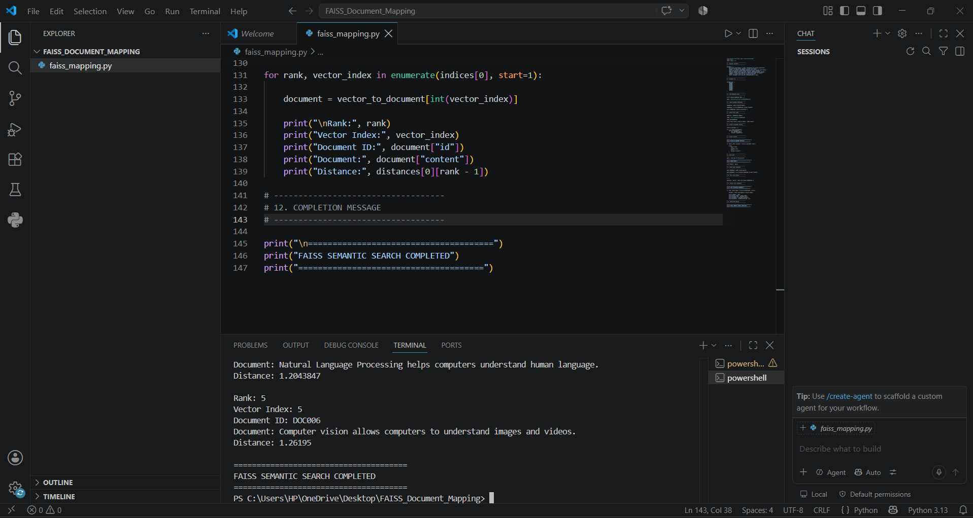
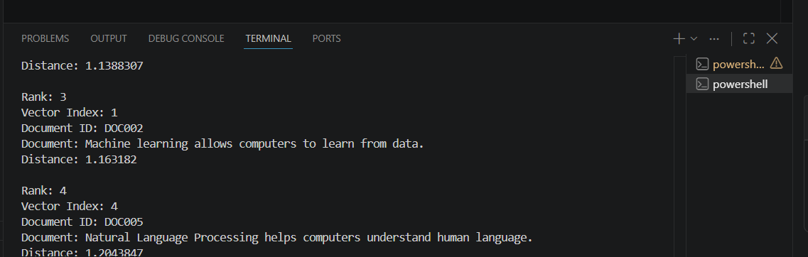
Working

Documents
↓
Sentence Transformer
↓
Document Embeddings
↓
FAISS Index
↓
User Query
↓
Query Embedding
↓
Top-5 Similarity Search
↓
Vector-to-Document Mapping
↓
Original Documents

Conclusion
The FAISS-based semantic search system was successfully implemented. Document embeddings were created and stored in a FAISS index, with each vector correctly mapped to its original document ID and content. The system successfully performed Top-5 similarity retrieval and displayed the corresponding documents. Correct vector-to-document mapping ensures accurate and reliable document retrieval.

Experiment 19: ChromaDB Dynamic Document Insertion
Aim
To develop a ChromaDB application that dynamically inserts new documents into a collection and verifies their retrieval using semantic search.
Objective
- Create a ChromaDB collection.
- Store documents and their embeddings.
- Dynamically insert a new document.
- Perform a semantic query after insertion.
- Verify whether the new document is retrieved.
- Analyze the behavior of ChromaDB after dynamic updates.
Requirements
- Python
- VS Code
- ChromaDB
- Sentence Transformers

Key Concept
Initially, the collection contains existing documents. A new document is inserted with its embedding. ChromaDB updates the collection, allowing the newly added document to participate in subsequent semantic searches.
Code
import chromadb
from sentence_transformers import SentenceTransformer
# -----------------------------------
# 1. Create ChromaDB client
# -----------------------------------
client = chromadb.PersistentClient(path="./chroma_data")
# Create or get collection
collection = client.get_or_create_collection(
name="documents"
)
# Load embedding model
model = SentenceTransformer("all-MiniLM-L6-v2")
print("ChromaDB collection created successfully.")
# -----------------------------------
# 2. Add initial documents
# -----------------------------------
initial_documents = [
"Python is a popular programming language.",
"Machine learning allows computers to learn from data.",
"Artificial Intelligence is used in healthcare."
]
initial_ids = [
"DOC001",
"DOC002",
"DOC003"
]
initial_embeddings = model.encode(initial_documents).tolist()
collection.upsert(
ids=initial_ids,
documents=initial_documents,
embeddings=initial_embeddings
)
print("Initial documents added successfully.")
# -----------------------------------
# 3. Display document count
# -----------------------------------
print("Documents in collection:", collection.count())
# -----------------------------------
# 4. Dynamically insert a new document
# -----------------------------------
new_document = "Deep learning is widely used in medical image analysis."
new_id = "DOC004"
new_embedding = model.encode([new_document]).tolist()
collection.add(
ids=[new_id],
documents=[new_document],
embeddings=new_embedding
)
print("\nNew document inserted dynamically:")
print(new_id, "->", new_document)
# -----------------------------------
# 5. Check updated collection
# -----------------------------------
print("\nDocuments after dynamic insertion:")
print("Total documents:", collection.count())
# -----------------------------------
# 6. Perform semantic query
# -----------------------------------
query = "How is AI used in medical imaging?"
query_embedding = model.encode([query]).tolist()
results = collection.query(
query_embeddings=query_embedding,
n_results=3
)
# -----------------------------------
# 7. Display search results
# -----------------------------------
print("\n======================================")
print("SEMANTIC SEARCH RESULTS")
print("======================================")
print("Query:", query)
for i in range(len(results["ids"][0])):
print("\nRank:", i + 1)
print("Document ID:", results["ids"][0][i])
print("Document:", results["documents"][0][i])
print("Distance:", results["distances"][0][i])
# -----------------------------------
# 8. Verify new document retrieval
# -----------------------------------
if new_id in results["ids"][0]:
print("\n======================================")
print("SUCCESS")
print("======================================")
print("The newly inserted document was retrieved.")
else:
print("\n======================================")
print("RESULT")
print("======================================")
print("The newly inserted document was not in the Top-3 results.")
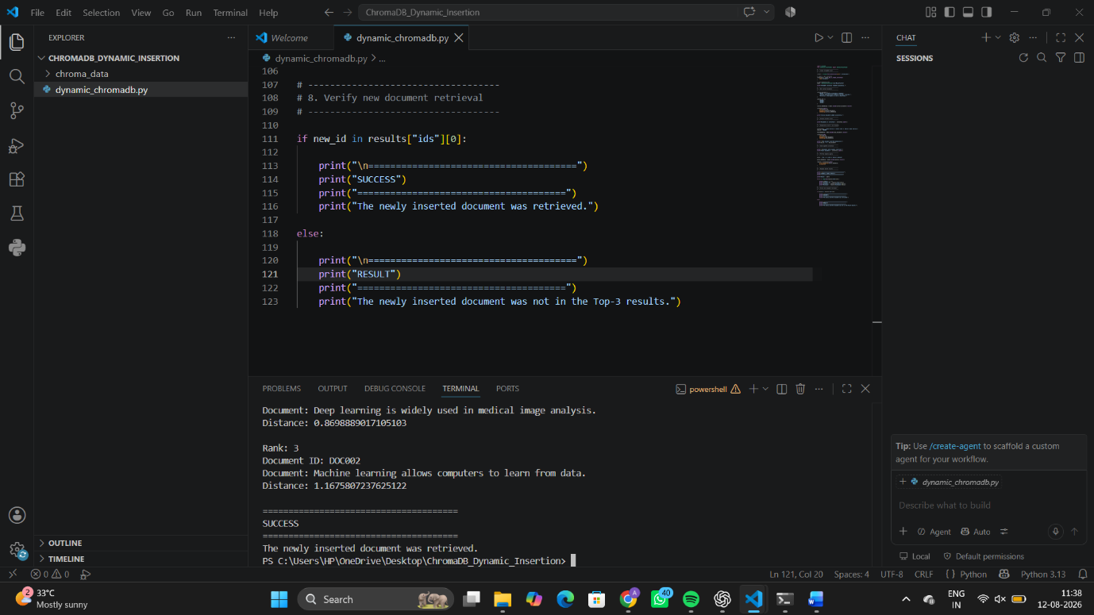
Working

Initial Documents
↓
Generate Embeddings
↓
ChromaDB Collection
↓
Dynamic Document Insertion
↓
Updated Collection
↓
Semantic Query
↓
Similarity Search
↓
Retrieved Documents
Conclusion
The ChromaDB dynamic document insertion system was successfully implemented. New documents were added dynamically to the collection, and semantic queries successfully searched the updated data. The experiment demonstrated that ChromaDB can efficiently handle dynamic updates and retrieve newly inserted documents based on semantic similarity.

Experiment 19: ChromaDB Dynamic Document Insertion
Aim
To develop a ChromaDB application that dynamically inserts new documents into a collection and verifies their retrieval using semantic search.
Objective
- Create a ChromaDB collection.
- Store documents and their embeddings.
- Dynamically insert a new document.
- Perform a semantic query after insertion.
- Verify whether the new document is retrieved.
- Analyze the behavior of ChromaDB after dynamic updates.

